1 Create numeric, character, and logical vectors and display type and content.

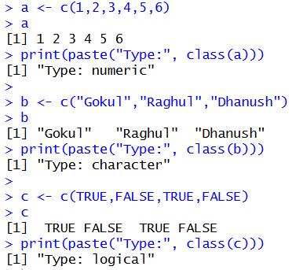

2. Create labeled matrices (5×4, 3×3, 2×2) filled by row/column.

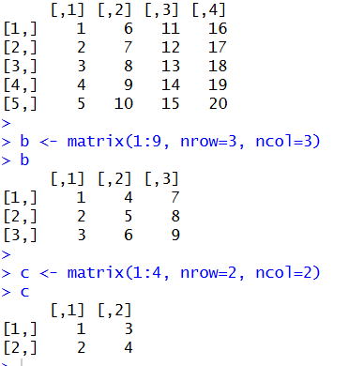

3. Write an R program to create and display a 3D array with specified rows,columns, and tables.

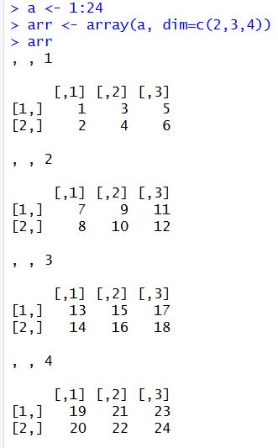

4. Create arrays from vectors with dimension names, print specific elements.
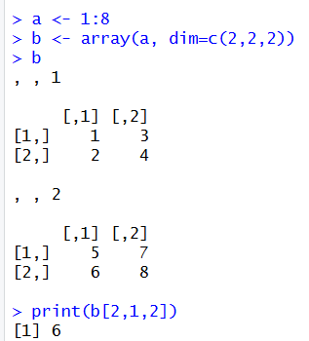

5. Create and manipulate factor variables (e.g., women’s dataset heights, random
LETTERS sample).
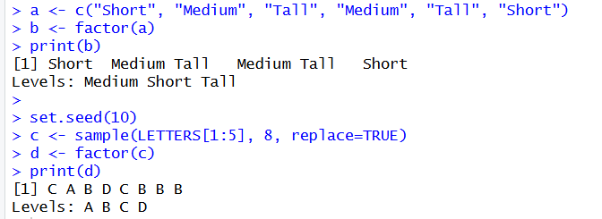

- Functions with Default Argument Values

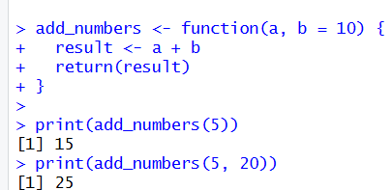

- Return Values and Explicit return()
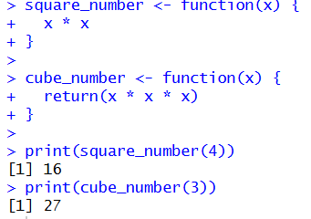
- Returning Complex Objects from Functions
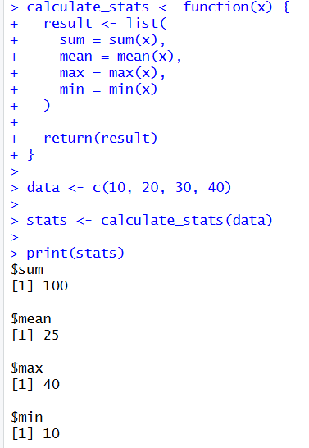

- Functions are Objects in R
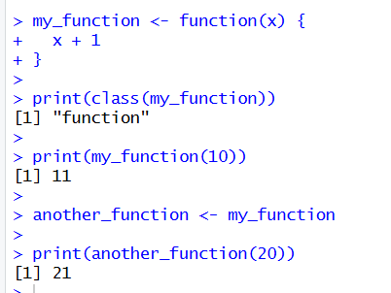
- Recursion in R – Factorial Program
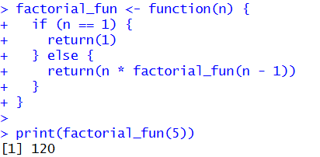

11. Read a CSV File and Display Its Contents

data <- data.frame(x = c(10, 20, 30, 50))
write.csv(data, "students_copy.csv", row.names = FALSE)
data <- read.csv("students_copy.csv")
print("Contents of the CSV file:")
print(data)
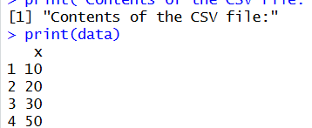

12. Calculate Monthly Averages Using the Airquality Dataset
data("airquality")
result <- aggregate(
cbind(Ozone, Solar.R, Wind, Temp) ~ Month,
data = airquality,
FUN = mean,
na.rm = TRUE
)

print("Monthly average values:")
print(result)
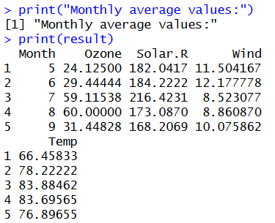
13: Combine Multiple Arrays Row-Wise
a <- c(1, 2, 3)
b <- c(4, 5, 6)
c <- c(7, 8, 9)
d <- rbind(a, b, c)
print("Combined arrays (row-wise):")
print(d)
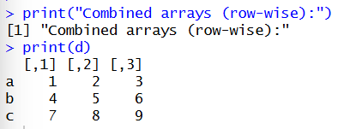

14: Explore and Manipulate the ChickWeight Dataset
data("ChickWeight")
head(ChickWeight)
sorted <- ChickWeight[order(ChickWeight$weight), ]
print("Sorted ChickWeight dataset:")
print(sorted)
print("Average weight by Diet:")
aggregate(weight ~ Diet, data = ChickWeight, FUN = mean)
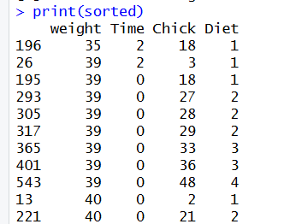
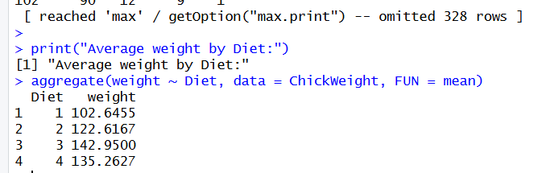

15: Perform EDA on the Iris Dataset

data("iris")
print("Dimensions:")
dim(iris)
print("Summary:")
summary(iris)
print("Standard deviation:")
sapply(iris[, 1:4], sd)
print("Quantiles of Sepal Length:")
quantile(iris$Sepal.Length)
print("Mean values grouped by Species:")
aggregate(. ~ Species, data = iris, FUN = mean)

print("Pivot table:")
table(iris$Species)
iris$Sepal_Category <- cut(
iris$Sepal.Length,
breaks = 3,
labels = c("Short", "Medium", "Long")
)
print("Sepal Length categories:")
table(iris$Sepal_Category)

